**Java**

Project Application: Agile process (Clients/PO'S: (User Stories)

Requirments--> Statements ---> Programs ---> Project --> Software/Application.

Developers --> Requirments --> programs ---> unit testing ---> applicatoin/software Testers --> Requirments --> Test Case Desgins --> Testing >Defects --> Ready

**Java - Programming Language + Runtime Environment**

**Programming Language :**

**By using programming languague we can create / develop a applications.**

int a = 10;

if (a== 10 ) {

//action1

} else {

//action2

}

**JDK (Java Development Kit):** It provides required tools to create / develop java programs or applications.

(or)

It provides an environment where we can create/develop java programs or apps.

Runtime Environment: It provides an environment where we can execute/run programs or applications.

**JRE(Java Runtime Envionrment):** It provides an environment where we can execute/run java programs or java applications.

Developer:

setup of JDK and JRE (Oracle)

JDK --> Tools + JRE

**Java :**

J2SE / Java SE – Standard Edition (Core Java) :

J2EE Java EE - Enterprise Edition (Adv Java)

~~J2EE Java ME – Mobile Edition (Not in use)~~

**Language Fundamentals:**

Class:

Person

**what do you have ? (Variables or Properties)**

height

weight

gender

skincolor

haricolor

name

**Sekhar**

height=5.5 weight=60

gender=Male

skincolor=balck

haircolor=black

name=sekhar

**what do you do? (Methods)**

eat()

sleep()

reading()

playing() writing()

**Class : it is combination of properties and behaviours (actions or methods)**

**Example:**

Mobile:

**what it has ?**

**Samsung S8**

Height height=3.5 in

Width width=3

Color color = blue

3 brand brand=samsung...

**what it does ?**

call()

sendMsg()

playGames()

**Class:** class is blue print or template for creating different objects which defines/have common properties and behaviours.

**Object:**

It is a Logical Entity.

Object have states (properties) and behaviours.

Object is physcially exists and we able to see, touch and modify it.

eg:

Madhu, BMW TS 99999, S8 99999

NOTE: Without class there is no chance of object can exists.

NOTE: Without class and object we cannot write any Single Java Program.

**Requirements** --> programs ---> class

class {

}

Properties (states)

Methods (actions/behaviours)

**Syntax of Class**:

<accessmofiers> class <classname> { // Start

1. Properties
2. Blocks
3. Constructors
4. Methods

} // end of the class

public class HelloWorld {

public static void main(String[] args) {

system.out.println("Welcome to Java");

}

}

**Save the program**

D:\\Examples

HelloWorld.java

HelloWorld.class **(byte code) (WORA 🡺 Write Once Run Anywhere)**

**Step1: Compilation**

javac HelloWorld.java

Path: It describes the location of where binary executables are there.

Syntax: path= C:\Program Files\Java\jdk1.8.0_291\bin

Class path:

**Step2: Execution / Run**

**java HelloWorld**

**java 🡪 It triggers/actives JRE**

**JVM 🡪Loads the HelloWorld.class from your hard disk into main memory**

**JVM 🡪 Internally on the fly convert byte code into machine understandable format and executing line by line and gives output.**

C:\Program Files\Java\jdk1.8.0_291\

|---bin (.exe files)

|--- **javac, java, javap...**

|---JRE

**Identifiers:**

A name in Java program is called an **Identifier**.

Name may be 🡪Class Name

* Method Name
* Variable Name
* Package Name

1. the only allowed characters in java identifiers are

1. a to Z

2. A to Z

3. 0 to 9

4. _,$

2. identifiers should not start with digit.

int empId;

int lempId; (invalid)

int _amount; //valid

int postalcode1; //valid

3. we cannot use reserved (keywords) as identifiers.

eg: if,else, for,while...

int if ;//invalid

4. Java identifiers are case sensitive.

main

Main

MAIN

int x=20;

int X=20

HelloWorld

HelloWorlD

helloWorld

**Reserved Words:**

1. keywords (50)

**keywords for data types:**

byte

short

int

long

float

double

boolean

char

**keywords for flow control:**

if else

switch

case

default

break

continue

do

while

for

**keywords for modifiers:**

public

protected

private

static

final

abstract

synchronized

native

strictfp

transient

voltaile

**keywords for exception handling:**

try

catch

finally

throw

throws

asserts

**Class related keywords:** **********************

class, interface, extends, implements, package, import

**Object related keywords:**

new, super, this, instanceof

void, enum

**2. Reserved Literals: (3)**

True, false, null

Literal means constant or fixed. We can’t change it.

**Data types:**

primitive data types:

byte

short

int

long

float

double

boolean

char

Reference data types: (**user defined or predefined**)

**Class Type / Interface Type**

eg:

HelloWorld 🡪 user defined

String 🡪 predefined

Integer

Employee

Customer

Runnable

int

empId=1001;

double empSalalry=28000.403;

long aadharId=344444444444;

boolean isEmpty = true; or false

char ch = 'Y';

String empName="Raja";

10 🡪 int (by default)

10.3 🡪double (by default)

10.3f 🡪 We have to mention f when we use float data type at the end.

**Methods:**

**syntax:**

**1 2 3 4**

<accessmofiders> <returntype> <methodname>(arg1, arg2, arg3....) { //method opening

//method body **(5)**

} // method ending

1,4 ---> Optionals

2,3,5 ---> Mandatory

eg: Perform addion of two numbers ( 10, 20) --> 1020 = 30

public class ArithmeticOpeations {

public int add(int firstNum, int second Num) { //logic

int result = firstNum + secondNum;

return result;

}

}

Methods 🡪 There are 2 types (**Instance method and Static method**)

**1.Instance Method:**

* If the method declaration doesn’t contain the keyword “**static**”, such type of methods are called as **Instance Method**.
* **Instance Method are part of Object.**
* **Using object, we invoke or call the instance method**

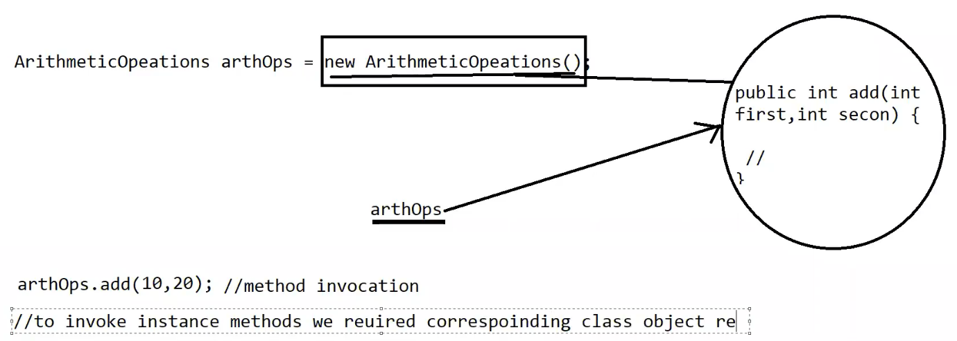

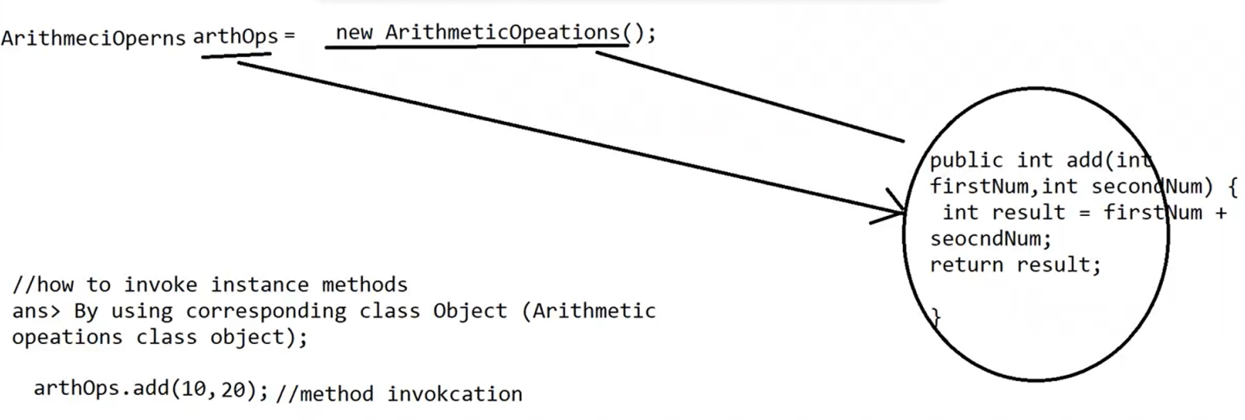

**How to create objects:**

**1 2 3 4 5**

<classname> <variablename> = new <classname>(arg1, arg2....);

// 1, 2,3,4 are mandatory

// 5 is optional

ArithmeticOpeations arthOps = new ArithmeticOpeations();

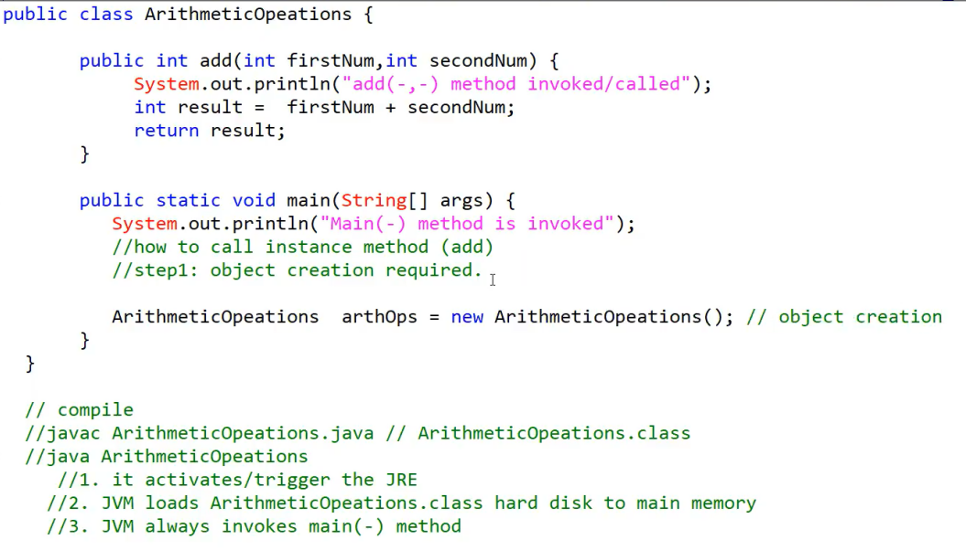

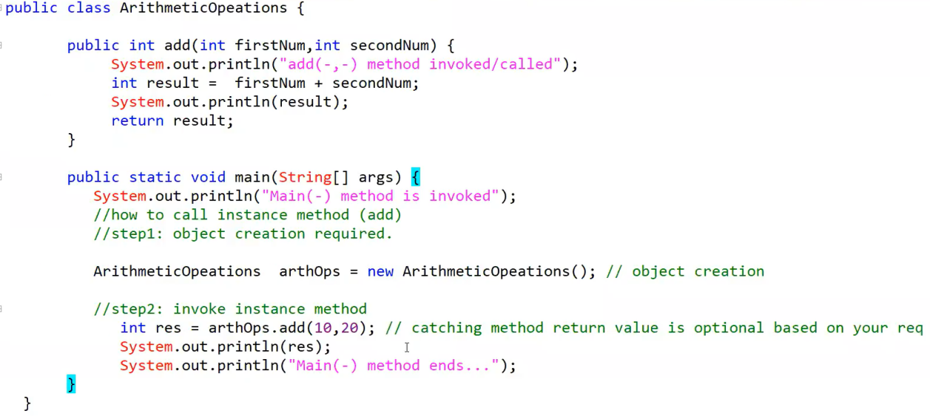

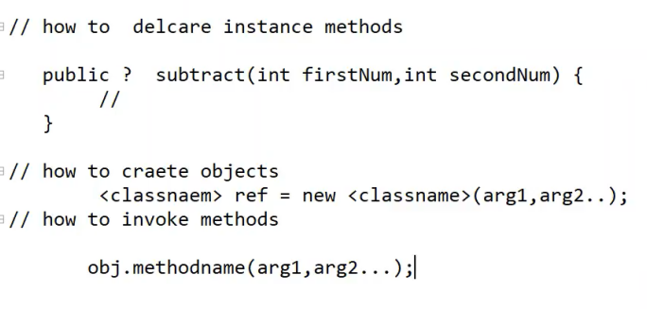

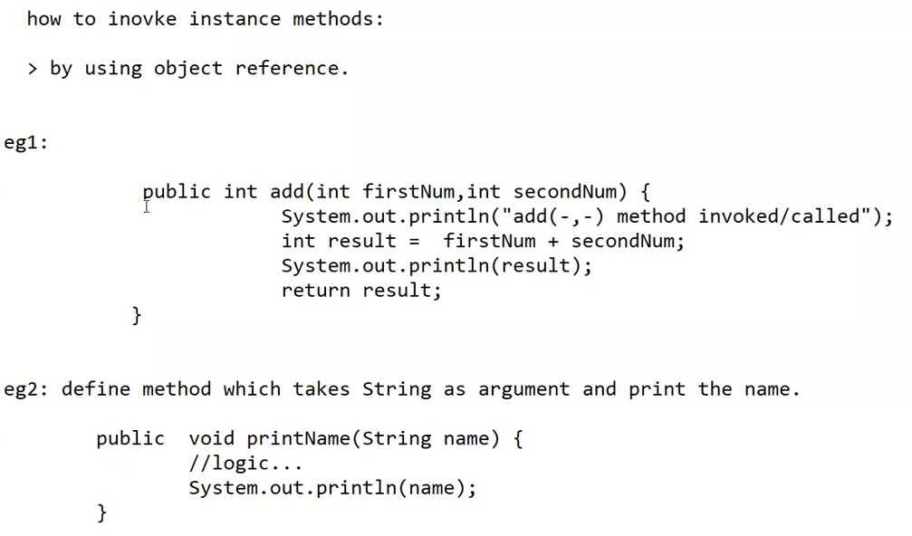

**Void 🡪 If the method is not returning anything then we have to declare the method return type as void.**

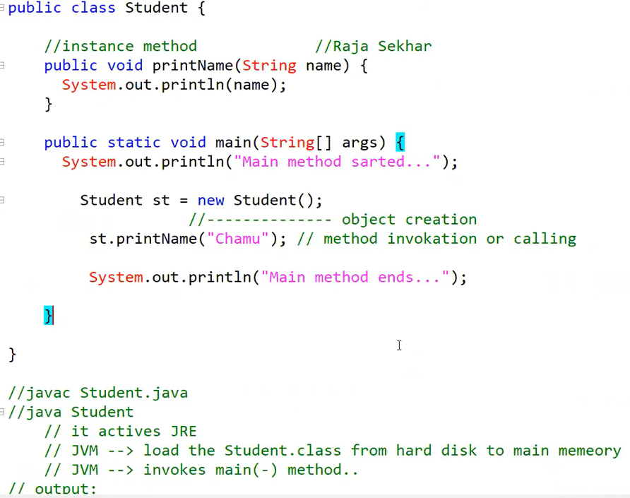

**2. Static methods:**

* If we declare a method with static key word, such type of methods are called

static methods. Static methods are at class level.(static methods are not part of Object).

public static void printMsg() {

}

System.out.println("Static method inovked...");

**How to invoke / call static methods:**

1. by using Class name **(Recommended)**

2. by using object reference (NOT recommended)

3. directly (without class name and object reference if and only if the method is in the same class). (NOT recommended)

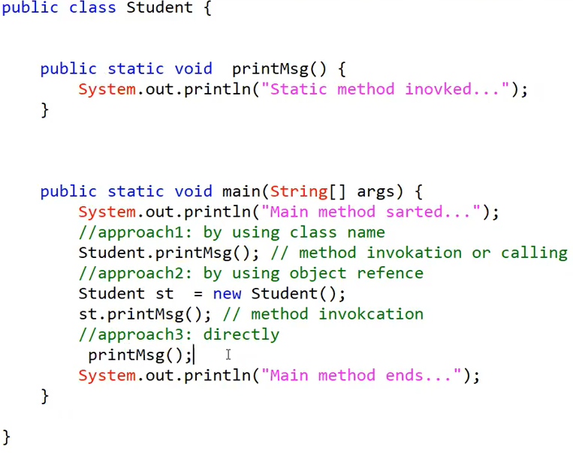

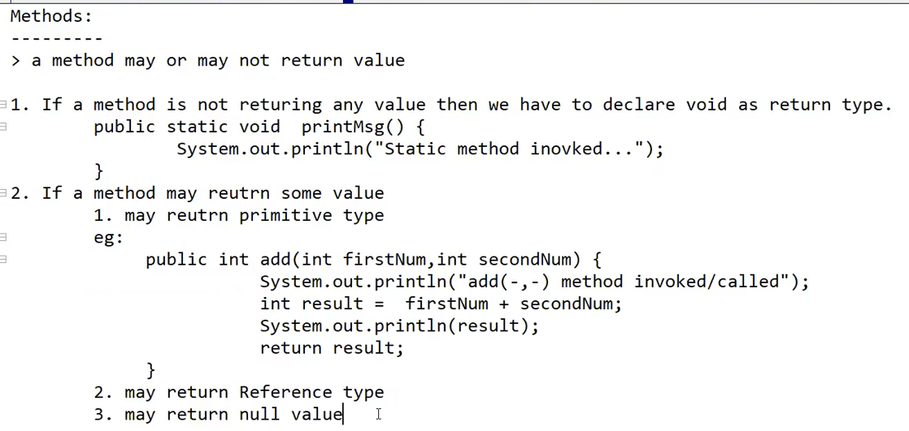

**Type of variables:**

1.instance variables/properties

2. static variables/properties

3. local variables/properties

**Class --> properties + methods**

**1. Instance variables/properties:**

public class Student {

int sid;

String sname;

String branchName;

static String universityName;

}

1. If the value of variable is varied/changed from object to object such type of variables are called instance variables.

2. Instance variables should be declared with-in the class directly  **i.e out side of method or block or constructor.**

3. Instance variables does not contain static key word.

**4. For every object a separate copy of instance variables will be created.  
5. It can be accessed by using object.**

**6. Instance variable will be created at the time of object creation and destroyed at the time of object destroyed. Hence, instance variables are exactly scope of the object.**

**7. Instance variables, we can’t access inside the static method directly, instead we have to access by using object only.**

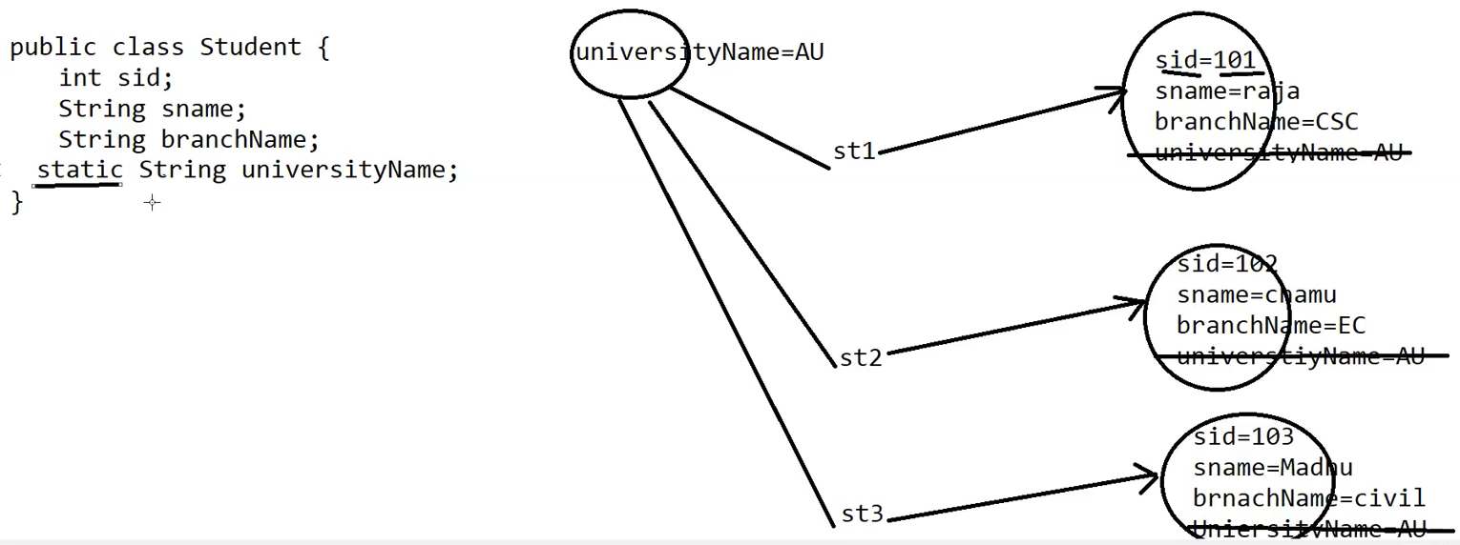

**2. Static variables/properites:**

1. If the value of variable is NOT varied/changed from object to object such type of variables are called static variables and we can declare with **static keyword**.

2. static variables should be declared with in the class directly **i.e out side of method or block or constructor.**

3. In case of instance variables for every object separate copy of instance variables will be created. **But, in case of static variables SINGLE (ONE) copy will be created at class level and shared by every object**

4. static variables can be accessed by using class name or object or directly (if it is available in same class)

**5. static variable will be created at the time of class load and destroyed at the time of class unload.**

**Class unload means 🡪 Program execution completes.**

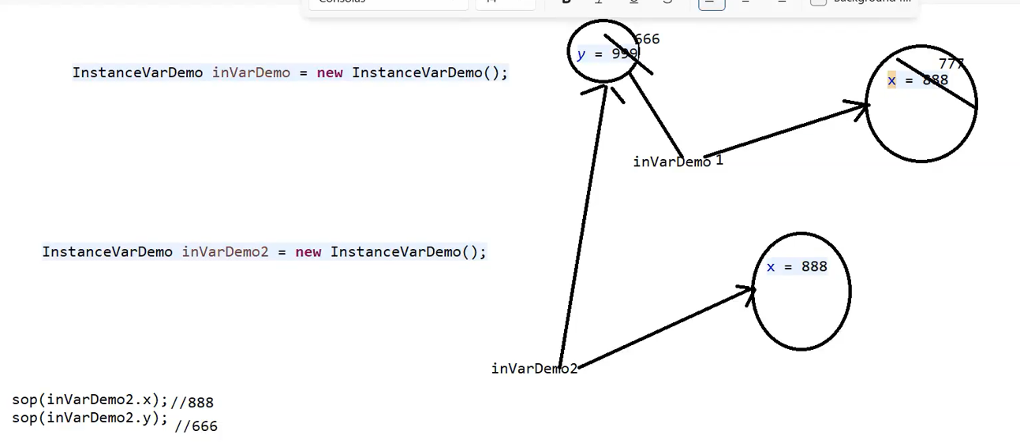

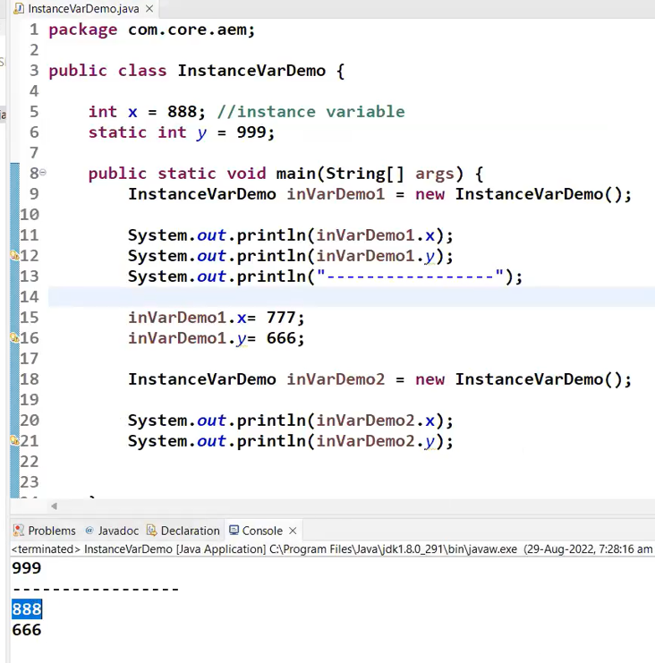

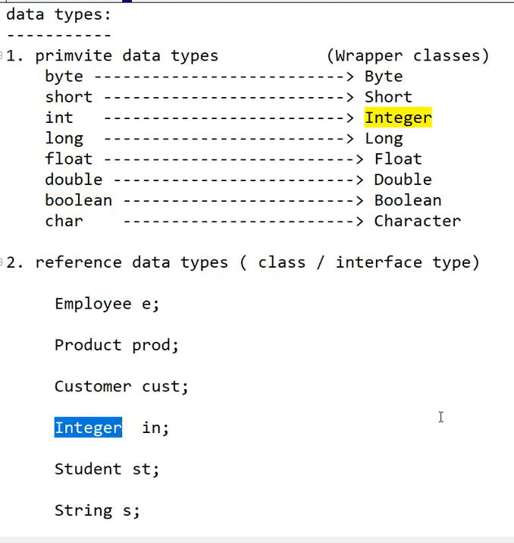

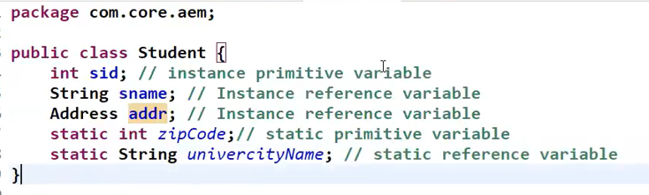

int x = 10; // x is primitive date type

Student st = new Student(); // st is a Reference data type

Employee e = new Employee(); // e is a reference data type

**NOTE: For instance/static variables for primitive data type JVM will provide default values, if we are not satisfied with default values then we can assign our own values.**

**Default value is:**

byte --0

short ---0

int----0

long---0

float--0.0

double---0.0

Boolean --- false

char—space

(**Instance/static variable – Reference data type JVM will provide “NULL” as a default value.**

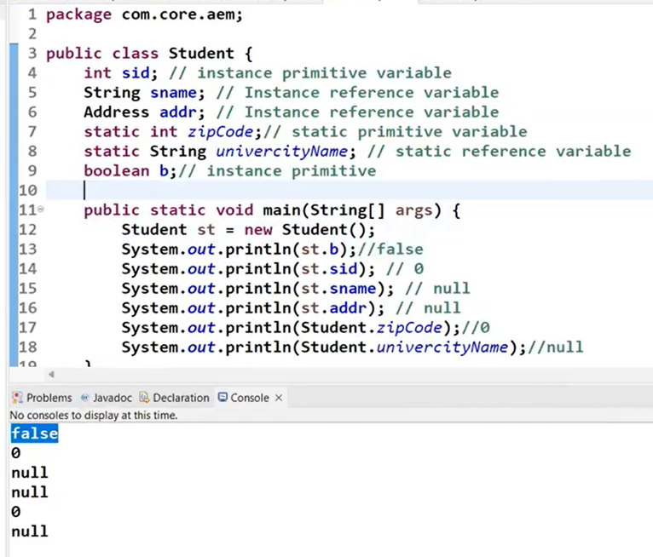

**Local Variables: (**local primitive & local reference)

1. some times to meet temporary requirements of the programmer we can declare variables inside a method or block or constructor such type of variables are called local varaibles.

public int add(int firstNum, int secondNum) {

System.out.println("add(-,-) method invoked/called");

int result =firstNum secondNum;

System.out.println(result);

return result;

}

> for local variables JVM won't provide any default values, before using local variables we have to provide values or at least default values.

> Local variables are stored in stack memory.

**JVM – Java Virtual Memory**

* **Heap Memory (Instance variable stores)**
* **Method Area (Static variables stores)**
* **Stack Memory (Local Variables stores)**

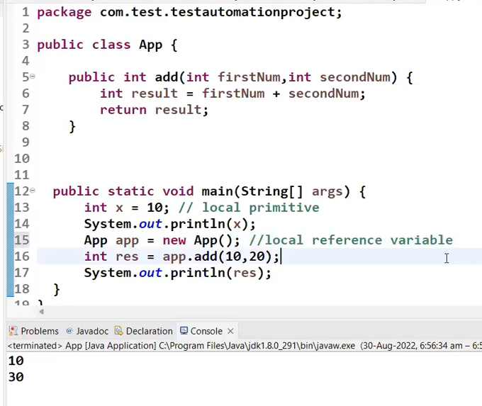

**Variables: (Conclusion)**

instance ---> instance primitive / reference

* Instance variable will be declared inside the class directly and outside of the method/block/constructor.
* When we create an object, the separate copy of instance variable will be created.
* JVM will provide a DEFAULT value.
* Access by using object

static ---> static primitive / reference

* Static variable will be declared inside the class directly and out side of the method/block/constructor.
* Should have static keyword
* SINGLE copy will be created commonly and shared to the object.
* JVM will provide a DEFAULT value
* JVM will provide a DEFAULT value for reference variable as NULL.
* Access by using class name (recommended), object, directly.

local ---> local primitive / reference

* It will be declared inside the method/block/constructor
* Before using local variables, we have to provide values or at least default values.
* JVM will NOT provide a DEFAULT value.

**Arrays:**

int empId1= 1001; int empId2 1002; int empId3= 1003; int empId4= 1004

int empId5= 1005;

;;

;;;

;;;

int empId1000=100000;

empId1, empId2, empId3, empId4,empId5 -🡪 variables

> **Array is an indexed collection of fixed number of same data elements.**

> The main advantage of arrays we represent huge/many number of values by using single variable So that required of the program code will be improved.

> The main disadvantage of the array is fixed in size i.e once we create an array there is no chance of decreasing or increasing the size.

**NOTE: In java index start from zero (0);**

**Step1: array declaration**

int[] empIds;

**Step2: array creation**

emplids = new int[10];

**Step3: array initialization**

empIds[0]=1001;

empIds [1]=1002;

empIds [2]=1003;

;;

;;

empIds [9]=1010;

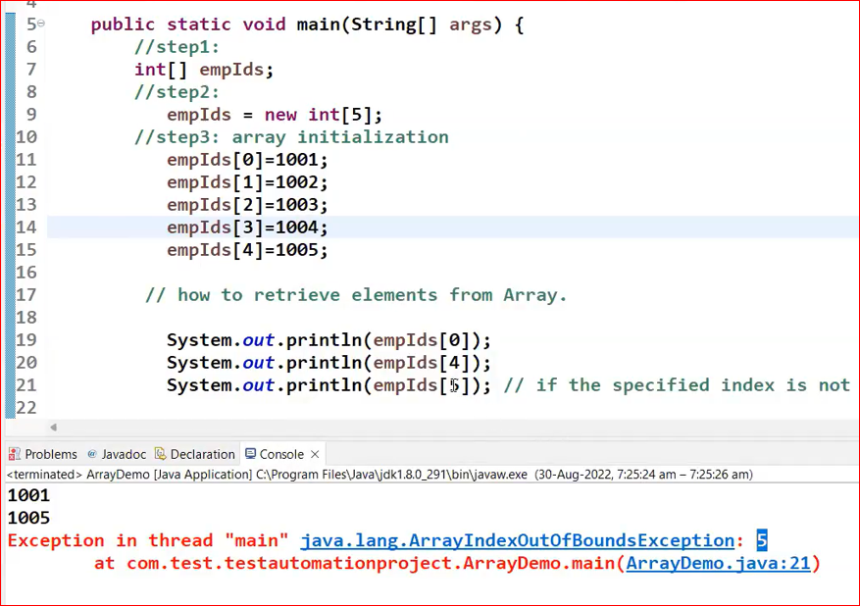

eg2: Array declaration and creation in the single line.

double[] empSalaryArr =new double[4];

empSalaryArr[0]=1001.10;

empSalaryArr[1]=1002.30;

empSalaryArr [2]=1003.20; empSalaryArr [3]=1004.40;

**eg3:**

String[] stNamesArr = new String[5];

stNamesArr[0] = "raja"; stNamesArr[1] = "sekhar";

Eg4:

public class Customer {

}

Customer[] custArr = new Customer[3];

Customer c1 = new Customer();

Customer c2 = new Customer();

Customer c3 = new Customer();

custArr[0]= c1;

custArr[1]= c2;

custArr[2]= c3;

public class Customer {

int cid=6666;

}

Customer[] custArr = new Customer[5];

Customer c1 = new Customer();

custArr[0] = c1;

System.out.println(qustArr[0].cid);

**2 Types of Array:**

1. Primitive array: it holds primitive values.
2. Reference array: it holds objects / references.

**› declaration, creation and initialization of array in single line:**

//declaration

int[] empIds;

//creation

empIds[] = new int[3];

//initialization

empIds [0]=1001;

empIds [1]=1002;

empIds [1]=1003;

**Single Line Array : Short form**

**int[] empIds = {1001, 1002, 1003, 1004, 1005};**

**How to find the size of the array:**

length is variable to find the size of the array.

int[] empIds ={1001,1002,1003, 1004, 1005};

System.out.println(empIds.length);

Or

**int** length = empIds .length;

System.***out***.println("Length is:"+length);

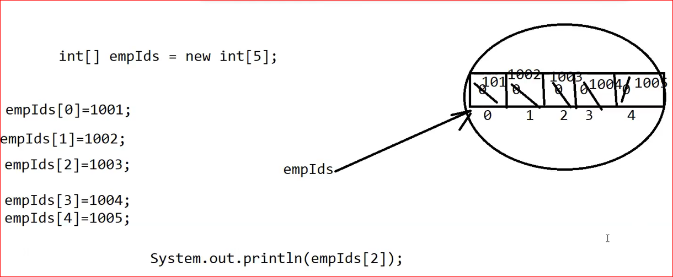

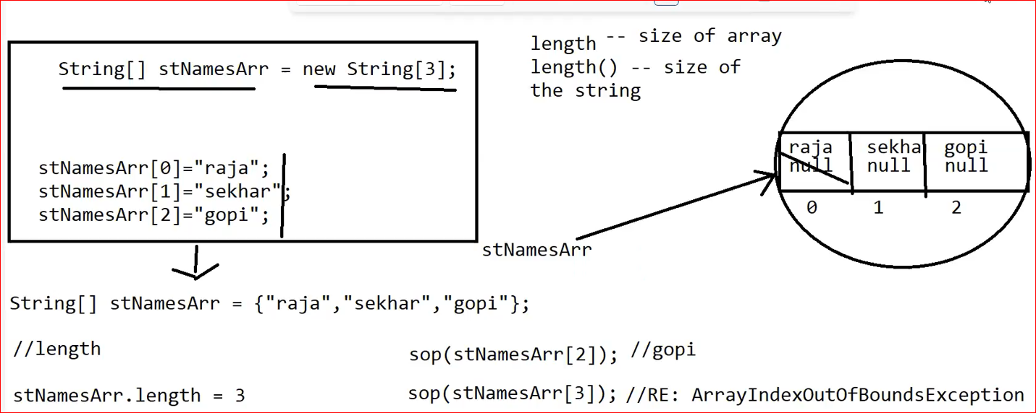

**Short Form of Creating Array:**

**\*\*\*\*\*\*\*\*\*\*\*\*\*\*\*\*\*\*\*\*\*\*\*\*\*\*\*\*\*\*\*\*\*\*\*\*\*\*\*\*\*\*\*\*\*\*\*\*\*\*\*\*\*\*\*\*\*\*\*\*\*\*\***

String[] SName={“Anbu”, “Inbha”, “Elakkiya”, “Ruku”};

**\*\*\*\*\*\*\*\*\*\*\*\*\*\*\*\*\*\*\*\*\*\*\*\*\*\*\*\*\*\*\*\*\*\*\*\*\*\*\*\*\*\*\*\*\*\*\*\*\*\*\*\*\*\*\*\*\*\*\*\*\*\*\***

**length 🡪 Find out size of the Array**

**length() 🡪 Find out size of the String**

**Operators:**

> new 🡪 for object creation

> [] 🡪 Array creation

**Increment/decrement operators: ( ++ , --)**

Increment operator (++):

> Pre Increment

int x = 10;

int y = ++x; // first increment x variable value and then assign to y variable.

Sop(x) 🡪11

Sop(y) 🡪 11

> Post Increment

int x = 10;

int y = x++; // first assign x variable value to y variable and then increment x value.

Sop(x) 🡪11

Sop(y)🡪10

**Arithmetic operators: (+, -, *, /, %)**

/ (division) = return Quotient (10/2=5)

% (modules) = return reminder (10/2=0)

+: if both arguments are number type then + acts as arithmetic addition.

10 20 30

: if at least one argument is String type then + acts String concatenation. "Result:" +10 Result:10

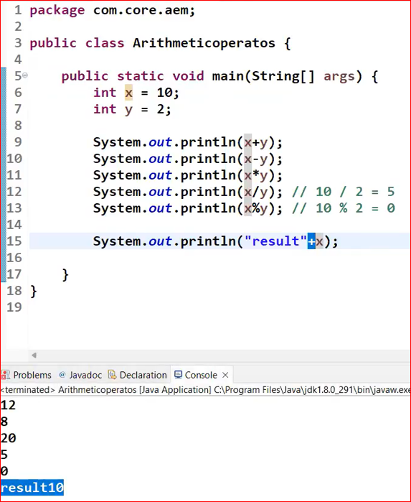

**Relational operators: (<, <=, >, >=)**

int x = 10;

int y = 20;

System.out.println( x < y); // true

System.out.println( x > y); // false

int k = 10;

int j = 20;

System.out.println( j >= k) ;| // true

System.out.println( j <= k) ;| // false

**NOTE: We can apply relational operator for every primitive data type except BOOLEAN**

**Ie. true > false // Invalid**

**Equality operators: (==, !=)**

🡪 to check the equality between two arguments / operands.

a== b

--> equality

a != b

--> not equal

**NOTE: we can apply equality operators even for object reference type also.**

if r1 == r2 returns true if and only if both r1 and r2 pointing to same object. i.e equality (==) operator meant for Object reference comparison or address comparison BUT NOT content comparison.

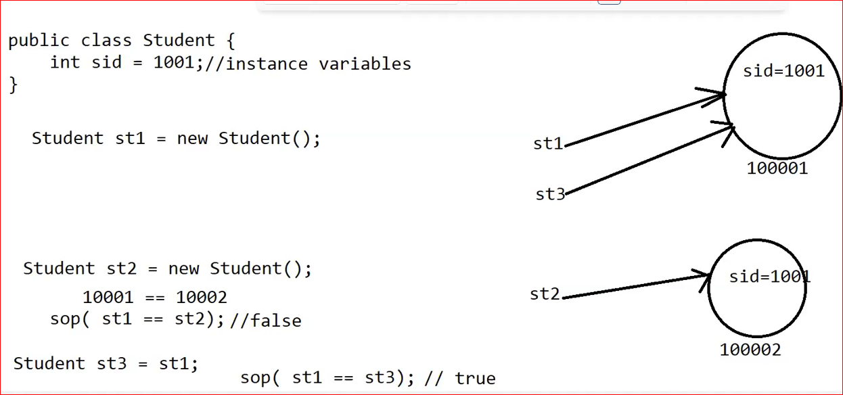

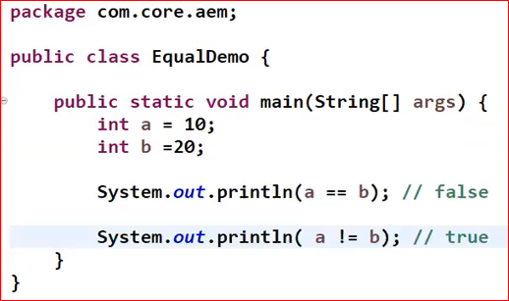

**In real time world, they use like below:**

**if(st1!=null){ // Object is not NULL**

**//action1**

**}**

**Else{**

**//action2**

**}**

**Short Circuiting operators: (&&, ||)**

**&& (Logical AND Operator):**

* **The && operator returns true if both operands (conditions) are true. If either operand is false, it returns false.**
* **It is a short-circuit operator, meaning if the first operand evaluates to false, the second operand is not evaluated, as the overall expression cannot be true.**

**Example:**

boolean a = true;

boolean b = false;

boolean result = a && b; // result is false

System.out.println(result); // Output: false

// Short-circuit example

int x = 5;

if (x > 0 && x < 10) {

System.out.println("x is between 0 and 10"); // This will execute

}

**|| (Logical OR Operator):**

* **The || operator returns true if at least one of the operands (conditions) is true. It returns false only if both operands are false.**
* **It is also a short-circuit operator, meaning if the first operand evaluates to true, the second operand is not evaluated, as the overall expression must be true.**

**Example:**

boolean c = true;

boolean d = false;

boolean result2 = c || d; // result2 is true

System.out.println(result2); // Output: true

// Short-circuit example

int y = 5;

if (y < 0 || y > 10) {

System.out.println("y is outside the range"); // This will not execute

} else {

System.out.println("y is within the range"); // This will execute

}

**Key Points**

* **Short-circuiting**: Both && and || stop evaluating as soon as the result is determined.
  + For &&, if the first condition is false, it doesn't check the second condition.
  + For ||, if the first condition is true, it doesn't check the second condition.
* Use && when you want both conditions to be true and || when you want at least one of the conditions to be true.

**Ternary operators: (? : )**

// Using ternary operator to find the maximum of two numbers

int max = (a > b) ? a : b;

**Assignment operators: (=)**

1. Simple Assignment Operator (=)

The simple assignment operator assigns the value on the right to the variable on the left.

Example:

int a = 10; // Assigns the value 10 to variable a

**2. Compound Assignment Operators**

These operators perform an arithmetic operation and assignment in one step. They are often used to simplify code.

* **Addition Assignment (+=)**: Adds the right operand to the left operand and assigns the result to the left operand.

int x = 5;

x += 3; // Equivalent to x = x + 3; Now x is 8

* **Subtraction Assignment (-=)**: Subtracts the right operand from the left operand and assigns the result to the left operand.

int y = 10;

y -= 2; // Equivalent to y = y - 2; Now y is 8

* **Multiplication Assignment (*=)**: Multiplies the left operand by the right operand and assigns the result to the left operand.

int z = 4;

z *= 5; // Equivalent to z = z * 5; Now z is 20

* **Division Assignment (/=)**: Divides the left operand by the right operand and assigns the result to the left operand.

int a = 20;

a /= 4; // Equivalent to a = a / 4; Now a is 5

* **Modulus Assignment (%=)**: Takes the modulus using the left and right operands and assigns the result to the left operand.

int b = 10;

b %= 3; // Equivalent to b = b % 3; Now b is 1

**Control Statement:**

**if ...else**

syntax:

if (b) {

}

else {

// if b is true then pefrom action1

// if b is false then pefrom action2

}

b --> should be boolean type.

int x = 2;

if( x == 2) {

//action1

}else{

//action2

}

**NOTE: else block and curly braces also optional, if we are not taking curly braces only one statement is allowed.**

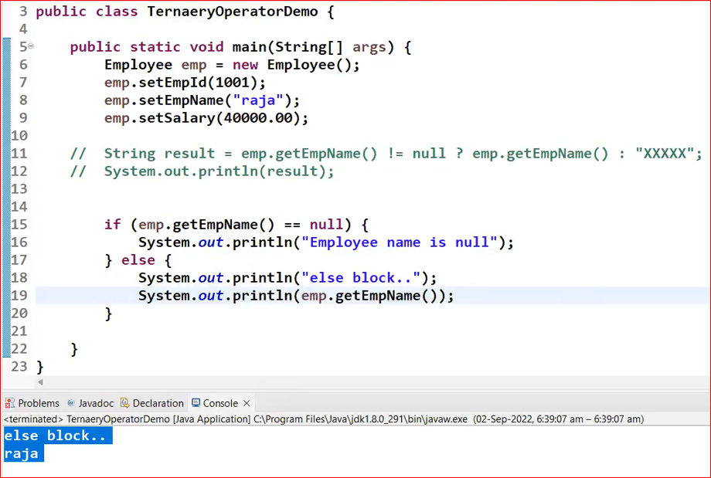

**If..elseif…elseif…elseif…else**

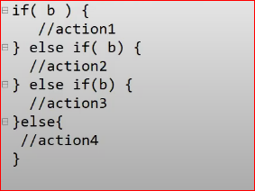

🡪We use “if..elseif…” when we have max 4 . More than 4, Recommended to go with switch…case statement

**switch statement:**

if we have several options then it is not recommended to use nested if else blocks bcz it reduces readability of the program, to handle this type of requirements we should go for switch statement.

**Syntax:**

switch(x){ // x 🡪switch argument is allowed, byte, short,int, char(primitive data type), Byte, Short, Integer, Character (Wrapper class), String.

case 1:

action1;

break;

case 2:

action2;

break;

case 3:

action3;

break;

case n:

action;

break;

default:

perform default action;

break; // Optional

}

Iterative Statement: (while, for, do..while)

🡪A group of statements will be executed repeatedly.

> while loop

> for loop

> do while

while loop If we don't know the number of iterations in advance then we should go for while loop.

.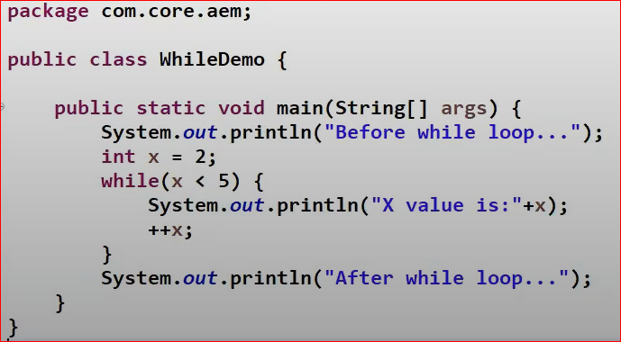

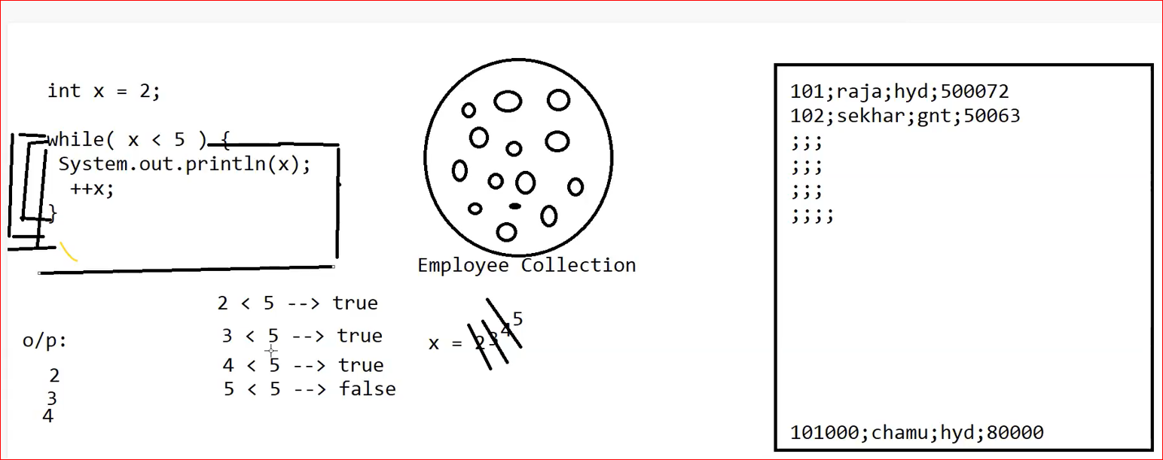

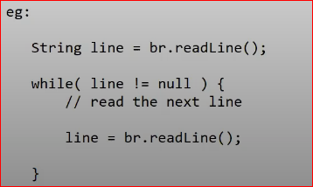

**for loop:** if you know the number of iterations in advance then we should go for loop.

syntax:

for(intializationsection condtionalexpression; increment/decremnt) {

// loop body

}

1.intialization section: It will be executed only once and generally we declared loop varibales in this section only.

eg: int i=1;

int i,j=1;

2.condtional expression here we can take any java valid expression but result should be Boolean type.

eg: i < 5 ; // expression result should be booean type

3.increment/decrement

In this section we can take increment/decrement the loop variables.

i++ or i—

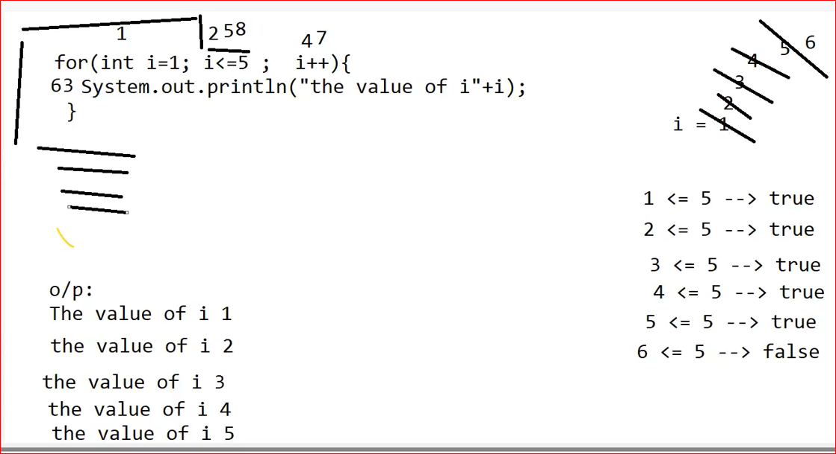

**Enhanced for loop or for each loop:**

Java 1. 5

**> To retrieve elements from Arrays or Collections.**

**For Loop:**

int[] empIdArr = {1001,1002,1003,1004};

for(int i=0;i<empIdArr.length;i++) {

System.out.println(empIdArr[i]);

}

**Enhanced For Loop or For each loop:**

for(int empId:empIdArr) {

System.out.println(empId);

}

String[] stNamesArr = {"raja", "sekhar", "madhu"};

for(String sName:empIdArr) {

System.out.println(sName);

}

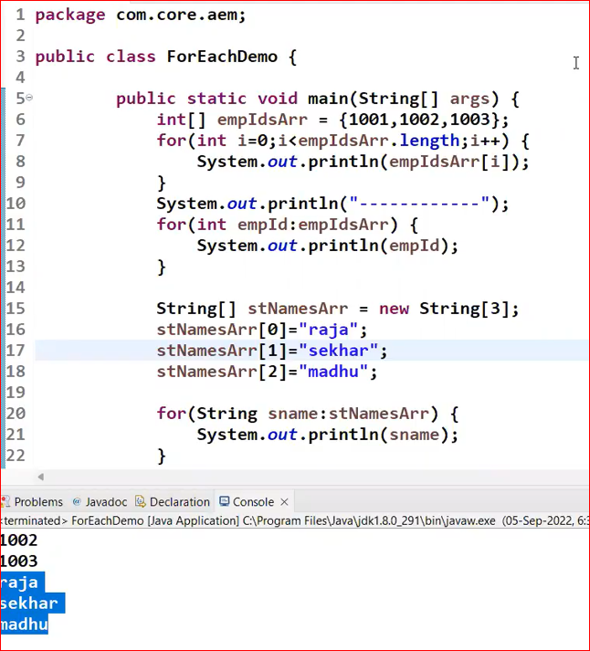

**Transfer statements:**

=> **break** It can be used in loops and switch statement.

loops: based on some conditions to exit from loop body.

=> **continue** it can be used in ONLY in loops, to skip the current iteration and continue the next iteration.

=> **return** – used to return value on method.

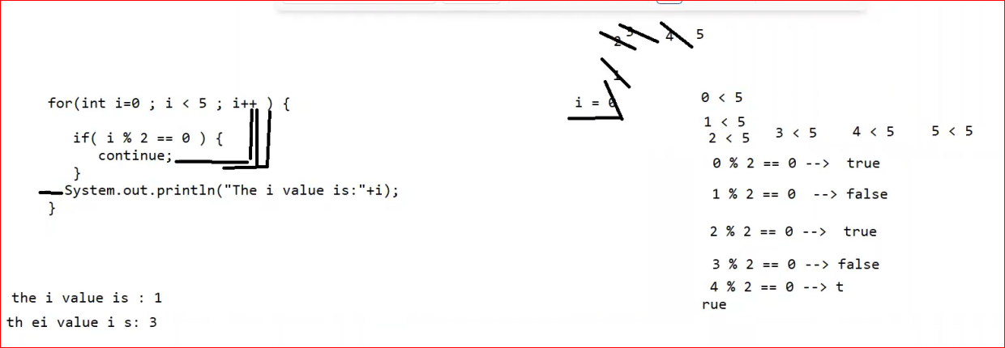

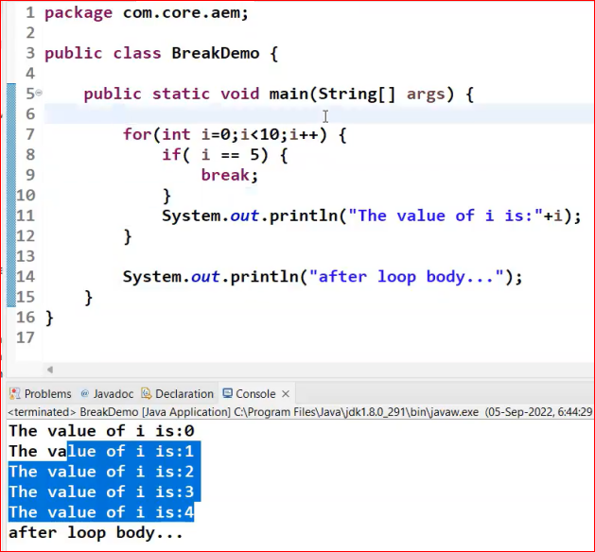

**Package🡪** It is a folder

In realtime, the package name should be reverse of the domain name with module name 🡪 com.olamagri.util

* **To resolve naming conflicts**

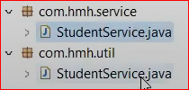

* **To improve the modularity of an application**

In computer

-D:\ || - - - -

-images | - - - - -

---birthday

*.jpg

- - --marriage

*.jpg

Requirments ---> programs --> classes / interfaces

> business (services)

> databse (db)

> secuirty (secuirty)

> admin (admin)

**syntax:**

**package <package name>.<modulename>.<submodulename>**

eg: package pack1;

<package name> :

Project ---> Client (JPMC) --> [www.jpmc.com](http://www.jpmc.com)

package com.jpmc.services;

pacakge com.jpmc.admin;

pacakge com.jpmc.db;

package com.jpmc.aem.core;

HMH ---> www.hmh.com

package com.hmh.core;

package com.hmh.security;

**Import:**

Requirements 🡪 Programs 🡪 classes/interfaces

Syntax:

**import <packagename>.<classname>;**

* If we call a class from one package to another, need to use import.
* If we call a one class to another class in same package, no need IMPORT.

**Access Modifiers:**

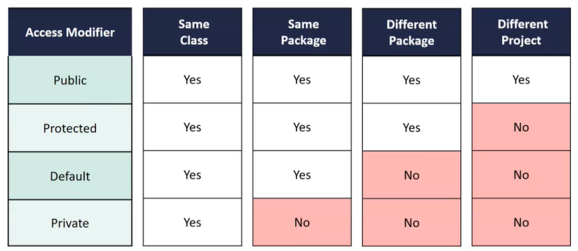

**Access Modifiers:**

> public

> protected

> default

> private

**class level modifiers:**

**public**: if a class declared as public then we can access that class from anywhere.

StudentService is public class then that class is access in any other class of same package or different pacakge.

<accessmodifers> class <nameoftheclass> {

}

NOTE: Recommended modifier for classes is "public".

**protected**:

🡪It is not applicable for outer classes. But it can be applicable for inner classes.

eg: protected class Person { // Invalid

public class Student {

}

}

public class Person {

protected class Student { // Valid

}

}

Person -> outer class

Student ---> Inner class

**private**: (Similar to protected)

🡪It is not applicable for outer classes. But it can be applicable for inner classes.

eg: protected class Person { // Invalid

public class Student {

}

}

public class Person {

protected class Student { // Valid

}

}

Person -> outer class

Student ---> Inner class

**default:**

1. if we are not writing any access modifier in front of the class key word then it is a default class.

2. If a class declared as the "**default**" then we can access that class only with in the same package hence default access is also known as **package level access**.

class StudentService {

}

**Members level modifiers ( Methods (instance & static) and Properties/Variables (instance & static):**

> It may be **method**(instance/static) or **variable** (instance/static)

**public members:**

If a member declared as public, then we can access that member from anywhere, but corresponding class must be visible. hence before checking member visibility, we have to check class visibility.

**default members:**

1. if we are not writing any access modifier in front of the method or variable then it is a default.

2. if a member declared as "default" then we can access that member only with in the current/same pacakge hence default member is also known as package level access.

int x = 10;

<accessmodifers> <returntype> <methoname> ( ag1, arg2..) {

}

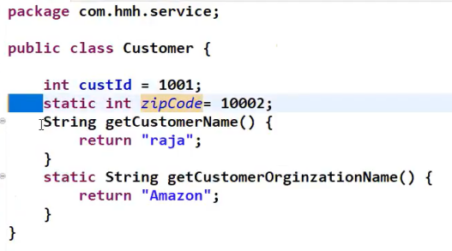

**private members:**

If a member is declared as private then we can access that member only with in CURRENT CLASS. Suppose by mistake if you try to access from outside of the class we can get compile time error.

**protected members:**

If a member declared as protected then we can access that member with in the same/current package anywhere but outside package ONLY in child classes.

**protected = default + kids (child classes) (This will be explained at the time OOPs concepts)**

**Conclusion on Members level modifiers:**

**Private (within same class) < default (Same package) < protected (Same package + ousite package only in child classes) < public (Anywhere)**

**\*\*\*\*\*\*\*\*\*\*\*\*\*\*\*\*\*\*\*\*\*\*\*\*\*\*\*\*\*\*\*\*\*\*\*\*\*\*\*\*\*\*\*\*\*\*\*\*\*\*\*\*\*\*\*\*\*\*\*\*\*\*\*\*\*\*\*\*\*\*\*\*\*\***

**NOTE: (In Software industry)**

* **recommended modifier for methods is "public"** (Using getter and setter)
* **recommended modifier for variables is "private"** (Using getter and setter)
* **recommended modifier for the class is "public"**

**NOTE: The only applicable modifier for local variables is "final"**

**final:**

It is a modifier applicable for classes, methods and variables.

> If a class declared as "**final**" then Inheritance concept is not applicable.

> If a method declared as "**final**" then overriding is not possible.

> if a variable declared as "**final**" then re-assignment/change the value is not possible.

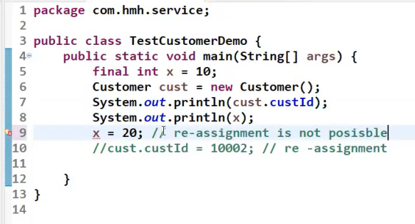

**IMPORTANT POINT ABOUT “package, import”:**

**User defined classes:**

Customer

Employee

Product

Student

**Pre-defined classes:**

String

Collection

List

**In Java, JDK provides more than 70K classes / interfaces in the form of Java API.**

**API is collection of packages.**

**java.lang package**

String

Integer

System

**i.e the classes / interfaces present in java.lang package by default available in every java program. i.e no need to import.**

[**https://docs.oracle.com/javase/8/docs/api/**](https://docs.oracle.com/javase/8/docs/api/)

**\*\*\*\*\*\*\*\*\*\*\*\*\*\*\*\*\*\*\*\*\*\*\*\*\*\*\*\*\*\*\*\*\*\*\*\*\*\*\*\*\*\*\*\*\*\*\*\*\*\*\*\*\*\*\*\*\*\*\*\*\*\*\*\*\*\*\*\*\*\*\*\*\*\*\*\*\*\*\***

**OOPs:**

**1. Inheritance (is-a relationship) (extends keyword)**

**2. has - a relationship**

**3. super vs this**

**4. constructor**

**5. polymorphism**

**> Method overloading**

**> Method overriding**

**6. abstract class vs interfaces**

**1. Inheritance: (Code re-usability using extends keyword)**

1. is a relationship also called inheritance.

2. by using "extends" key words we can implement is-a relationship.

3. the main advantage of is-a relationship is "**code reusability**".

Inheritance allows a class to use the properties and methods of another class.

In other words, The Derived class inherits the properties and methods from Base class.

Parent / Base / Super class

Child / Derived / Sub class

* It having it’s own additional properties and methods.

Syntax:

public class Parent{ // Recommended having common properties & method in the parent/base/super class

//Properties

// Methods

}

public class Child extends Parent{

// Parent Properties & Methods

// Also Child specific properties and methods.

}

Example:

public class Person {

// properties

// methods

}

public class Student extends Person {

// person properties & methods

// student specific properties

// student specific methods

}

public class Employee extends Person {

// // Person properties & methods

// Employee specific properties

// Employee specific methods

}

**IMPORTANT conclusion:**

public class Parent {

public void foo() {

System.out.println("Parent class foo() method..");

}

}

public class Child extends Parent {

public void fooBar(){

System.out.println("child class fooBar() method..");

}

}

**conculsion1:**

whatever(properties and methods) the parents has by default available to child hence on the child class reference we can call both Parent and Child specific methods and properties.

**conclusion2:**

whatever methods and properties child has by default NOT available to Parent and hence on the Parent reference we cannot call child specific methods and properties.

Eg.

Parent parent=new Parent();

parent.foo() // Valid

parent.fooBar(); // We can’t call child class method in parent. It will throw compile time error.

**conclusion3:** **************************************

Parent class reference can be used to hold Chlid class object but by using that reference we cannot call child specific methods and properties but we can call methods and properties present in Parent Class.

Eg.

Parent parent = **new Child(); // Valid**

parent.fooBar(); // Compile time Error

parent.foo(); // valid, because it’s in parent class method.

**conclustion4:\*\*\*\*\*\*\*\*\*\*\*\*\*\*\*\*\*\*\*\*\*\*\*\*\*\*\*\*\*\*\*\*\*\*\*\*\*\*\*\*\*\***

Parent class reference can be used to hold child class object but Child class reference cannot be used to hold Parent class Object.

Eg.

Parent parent = new Child(); // Valid

Child child = new Parent(); // Invalid, Compile time Error

**without inheritance:**

public class PersonalLoan {

public boolean validatePersonalDetails (Person person) {

// logic...

}

public doulbe getCreditScore(Person p) {

//logic

}

}

public class HomeLoan {

public boolean validatePersonalDetails (Person person) {

// logic...

}

public doulbe getCreditScore(Person p) {

//logic

}

}

public class VehicleLoan {

public boolean validatePersonalDetails (Person person) {

// logic...

}

public doulbe getCreditScore(Person p) {

//logic

}

}

**with inheritance:**

public class Loan {

public boolean validatePersonal Details (Person person) {

// logic...

}

public doulbe checkCreditScore (Person p) {

//logic

}

}

public class PersonalLoan extends Loan {

// PersonalLoan specific logic

}

public class HomeLoan extends Loan {

// HomeLoan specific logic

}

public class VehicleLoan extends Loan {

// Vehicle specific logic

}

NOTE: The most common methods/properties / common logic which are applicable for any type of child classes we have to define in Parent class.

The specific methods/properties logic which are applicable for a particular child we have to define in child class.

**JDK ---> java.lang.Object (Class) 🡪 It’s a SUPER CLASS for all classes in Java (Pre-defined/user defined)**

**Eg.**

Employee

String

Integer

The most common methods/common logic applicable for all classes in java, defined in **java.lang.Object** class, hence **java.lang.Object** class acts as Super class /Base class/ Root class for all classes in java

If our class is not extends any other class then our class is direct child of **class** **Object**.

Object

|

Person

If our class extends any other class then our class is indirect child class of Object.

Object

|

Person

|

Student

🡪Person is a direct child class of Object

🡪Student is a indirect child class of Object.

******************************************************************************

**has-a relationship: ********************* (VERY IMPORTANT 90% OF AEM USES THIS)**

> has-a means an instance (object) of one class "has a" reference to an instance of another class or another instance of same class.

> It is also known as composition or aggregation.

> There is no specfic key word to implement has-a relationship but Mostly we are using "**new**" keyword.

> The main advantage of has-a relationship is "**code reusablity**".

Every Car has a ENGINE Reference ?

Every Employee has a ADDRESS Reference ?

Example:

public class Address {

private String streeName;

private int ploatNo;

private int roadNo;

//gettor

// settor

}

public class Employee { // the Employee class has a object reference of Address

int empId;

String empName;

Address address = new Address(); // In the real-time/AEM, the object will be created from container.

public void printEmployeeAddressDetails() {

System.out.println(address.getStreeName()+"."+address.getPlot No());

}

}

Getters 🡪 To retrieve the value

Setters 🡪 To set the value

**How to do:**

Right click on the program window, Source 🡪 Generate Getters & Setters

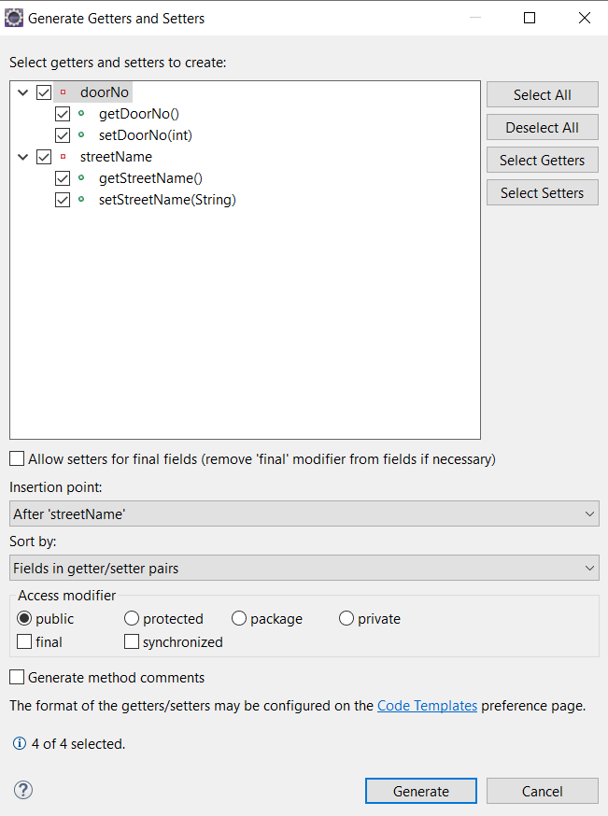

Example 1:

**Address.java**

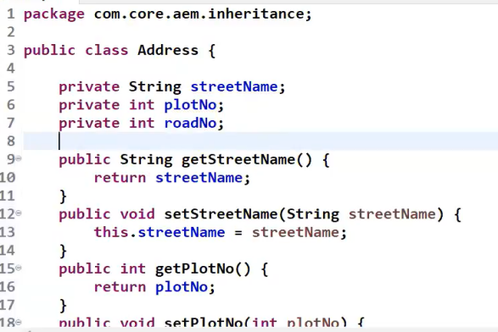

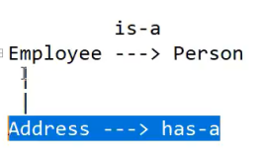

**Employee.java**

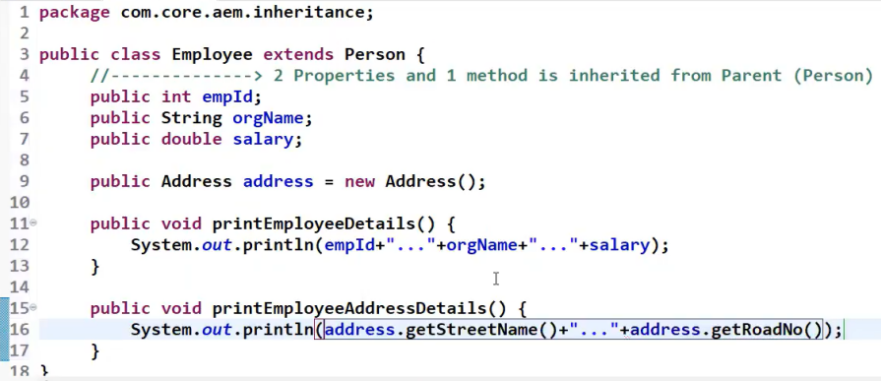

**TestEmp.java**

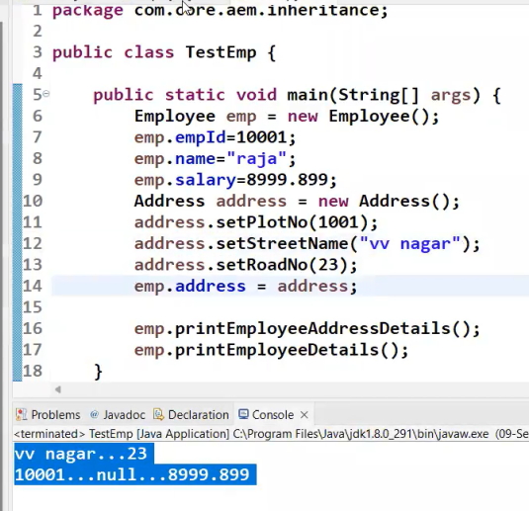

Example 2:

**Car.java**

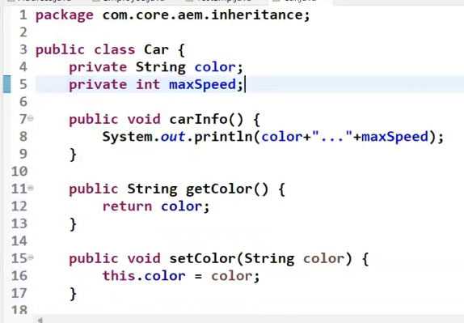

**Engineen.java**

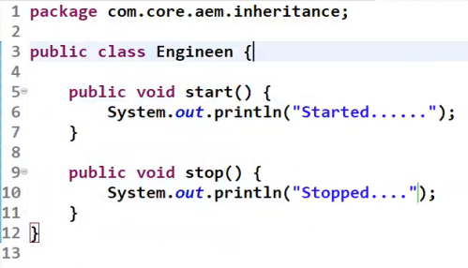

**BMWCar.java**

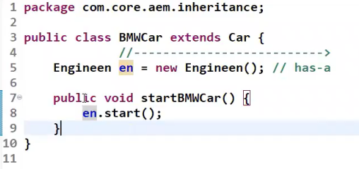

**TestBMWCar.java**

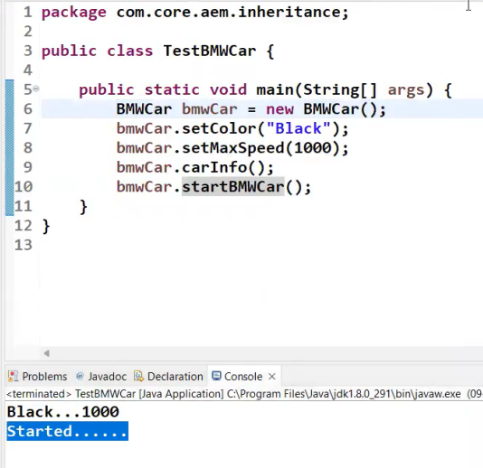

**\*\*\*\*\*\*\*\*\*\*\*\*\*\*\*\*\*\*\*\*\*\*\*\*\*\*\*\*\*\*\*\*\*\*\*\*\*\*\*\*\*\*\*\*\*\*\*\*\*\*\*\*\*\*\*\*\*\*\*\*\*\*\*\*\*\*\*\*\*\*\*\*\*\*\*\*\*\***

**When we go for “Has- a relationship”: In AEM**, using @Autowired, It will create an object and assign it.

**NOTE: if we want, a part of the functionality of one class then we should go for has-a relationship. It follows loosely coupling mechanism.**

**When we go for “is- a relationship”: (extends)**

**NOTE: if we want, total functionality of one class automatically then we should go for is-a relationship. It follows tightly coupling mechanism.**

**\*\*\*\*\*\*\*\*\*\*\*\*\*\*\*\*\*\*\*\*\*\*\*\*\*\*\*\*\*\*\*\*\*\*\*\*\*\*\*\*\*\*\*\*\*\*\*\*\*\*\*\*\*\*\*\*\*\*\*\*\*\*\*\*\*\*\*\*\*\*\*\*\*\*\*\*\*\***

**super vs this: \*\*\*\*\*\*\*\*\*\*\*\*\*\*\*\*\*\*\*\*\*\*\*\*\*\*\*\*\*\*\*\*\*\*\*\***

**> these are keywords in java.**

**> instance members (instance properties or instance methods)**

**super:**

**🡪 It is a keyword to access parent class instance members (variables & methods) from child class.**

**this:**

**> it is a keyword to access current class instance members (variables & methods).**

**> "this" represents current object**

**> "this" can be used to resolve ambiguity between instance variables and local variables.**

**Example:**

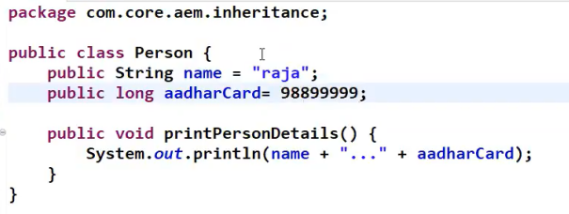

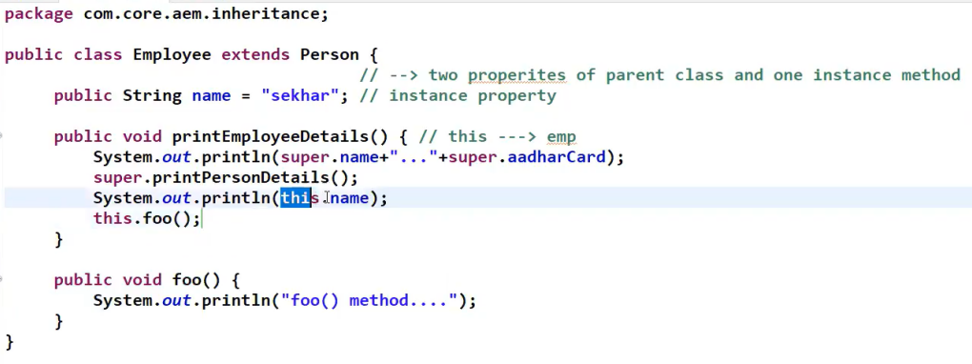

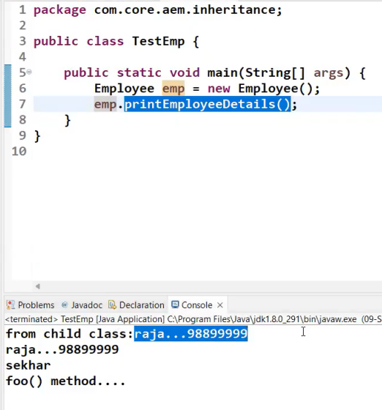

**Constructor:**

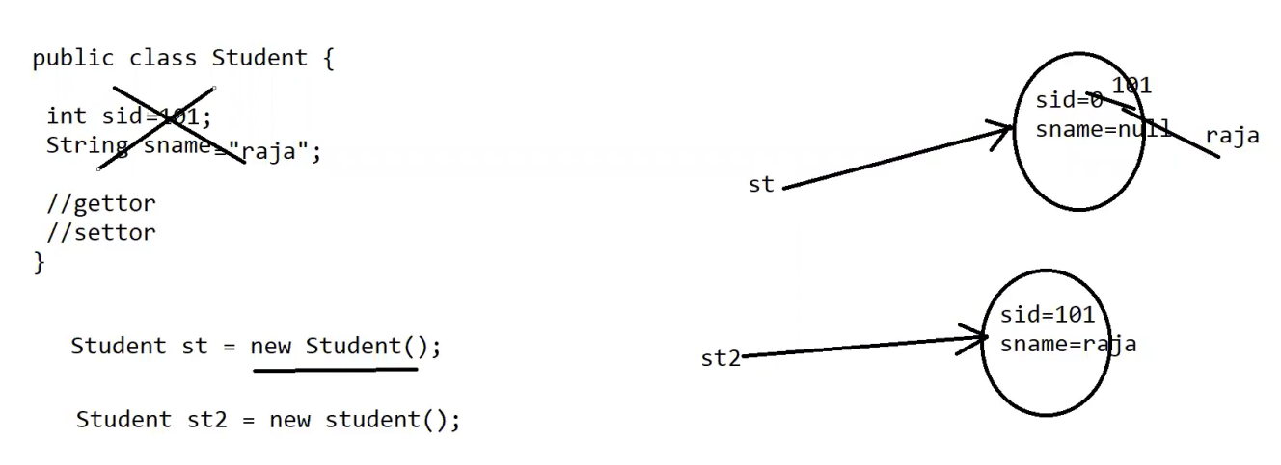

**Approach 1:**

public class Student {

int sid;

String sname;

}

Student st1 = new Student();

sop (stl.sid); // 0

sop (st1.sname); // null

**> Object creation is not enough compulsory we should perform initialization then only the object is in position to provide proper service hence after creation of the object compulsory we should perform initialization.**

**initialization of an object is ---> assigning the values to instance variables.**

**Approach 2:**

public class Student {

int sid = 101;

String sname= "raja";

}

The problem in this approach is, for every object same name and id hence this is not the recommended.

Student st1 = new Student();

sop(stl.sid); // 101 sop (st1.sname); // raja

Student st2 = new Student();

sop (st2.sid); // 101

sop(st2.sname); // raja

**Right Approach:**

> whenever we create an object some peace of code will be executed automatically to perform initialization of an object, this peace of code is nothing but **constructor**.

> the main objective of constructor is to perform initialization of an object.

> constructor should be same as class name.

**initialization of an object is ---> assigning the values to instance variables.**

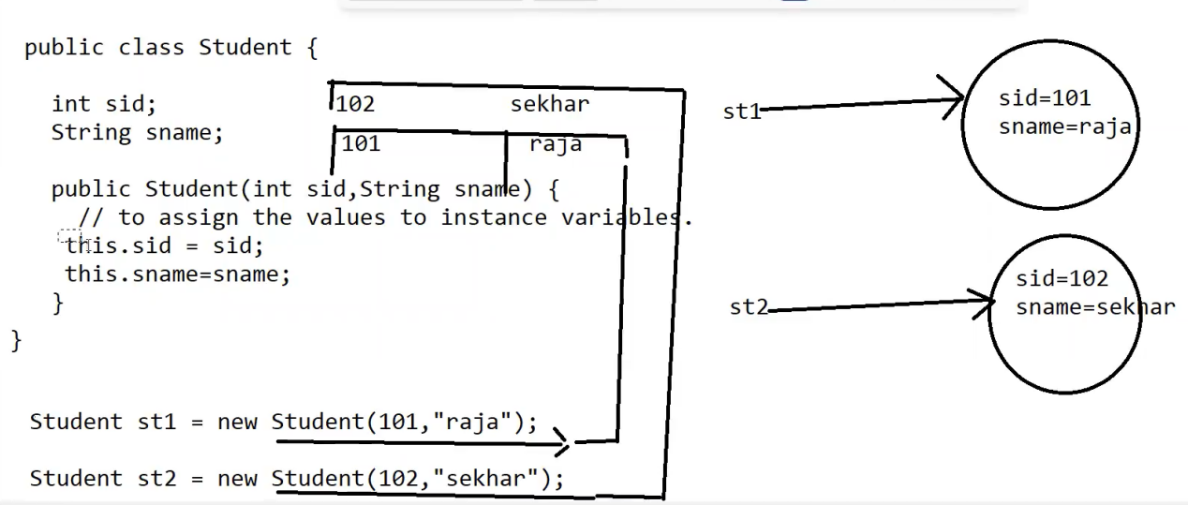

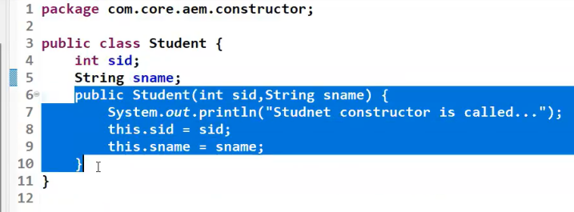

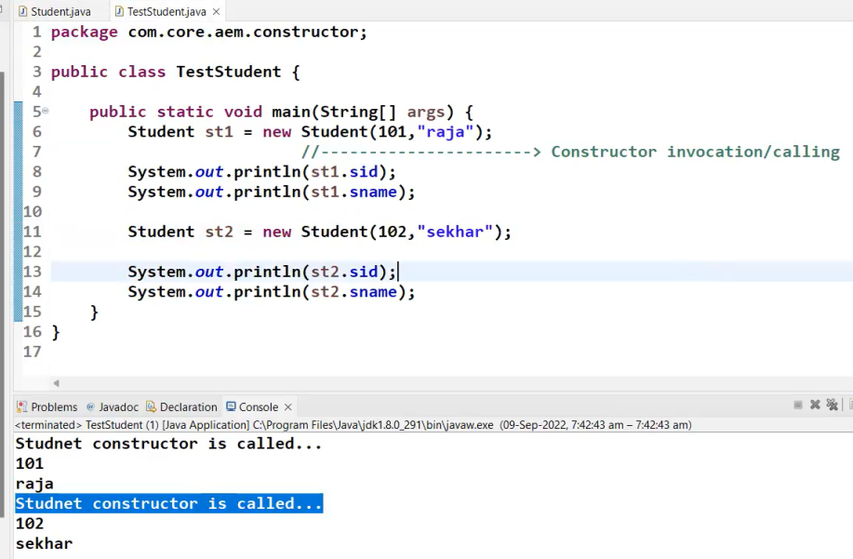

We can number of constructors…

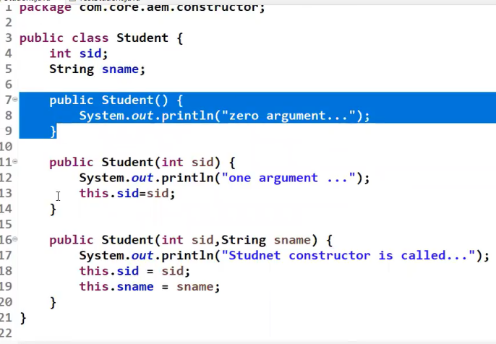

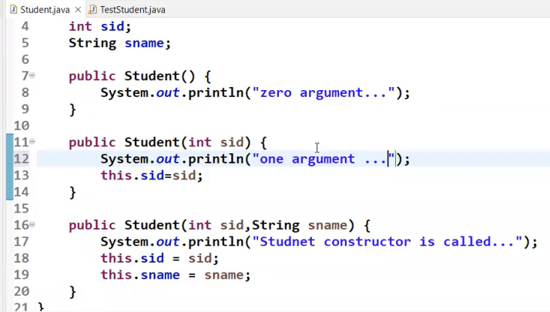

**Polymorphism:**

The word "ploy" means many and "morphs" means forms so **Polymorphism** means many forms.

" **Polymorphism** " is the ability of an object to take many forms.

"The most common use of **Polymorphism** in OOPS, Parent class/Interface reference can be used to hold child class object/Implementation class object.

public class Product {

}

public class K12Product extends Product {

}

public class DigitalProduct extends Product {

}

Product prod = new K12Product();

prod = new Digital Product();

List list = new ArrayList();

list = new LinkedList();

Type of **Polymorphism**:

There are two types of **Polymorphism** in java.

1. compile time **Polymorphism**

eg: Method overloading

2. runtime **Polymorphism**

eg: Method overriding.